Liquid Emissions Revenue Collection
1. Purpose
This document outlines the plan for developing a digital platform that automates the collection of ship emission fees in Nigerian ports. In simple terms, the platform helps government agencies and shipping companies pay and manage emission-related fees easily and transparently. At present, emission-related fees are not collected or processed through any centralised platform. This creates gaps in environmental compliance monitoring and prevents government agencies from capturing significant revenue that should come from vessel emissions.
The proposed system simplifies the process by allowing:
- Shipping companies calculate and pay emission fees online.
- Regulators to track and monitor compliance in real time.
- Government agencies to automatically receive revenue and generate financial reports.
Overall, this project aims to make emission fee collection more efficient, secure, and accountable — supporting environmental monitoring while improving revenue assurance for the maritime sector.
2. Product Goals
- Create a unified platform for managing and collecting emission-based fees for vessels operating in Nigerian waters.
- Enable real-time visibility for both ugovernment agencies and private operators.
- Support multiple payment methodsy (Naira, USD, and potentially stablecoins).
- Integrate with existing payment gateways for faster deployment.
- Improve accountability and reduce manual paperwork.
- Offer transparency in how fees are calculated, collected, and distributed.
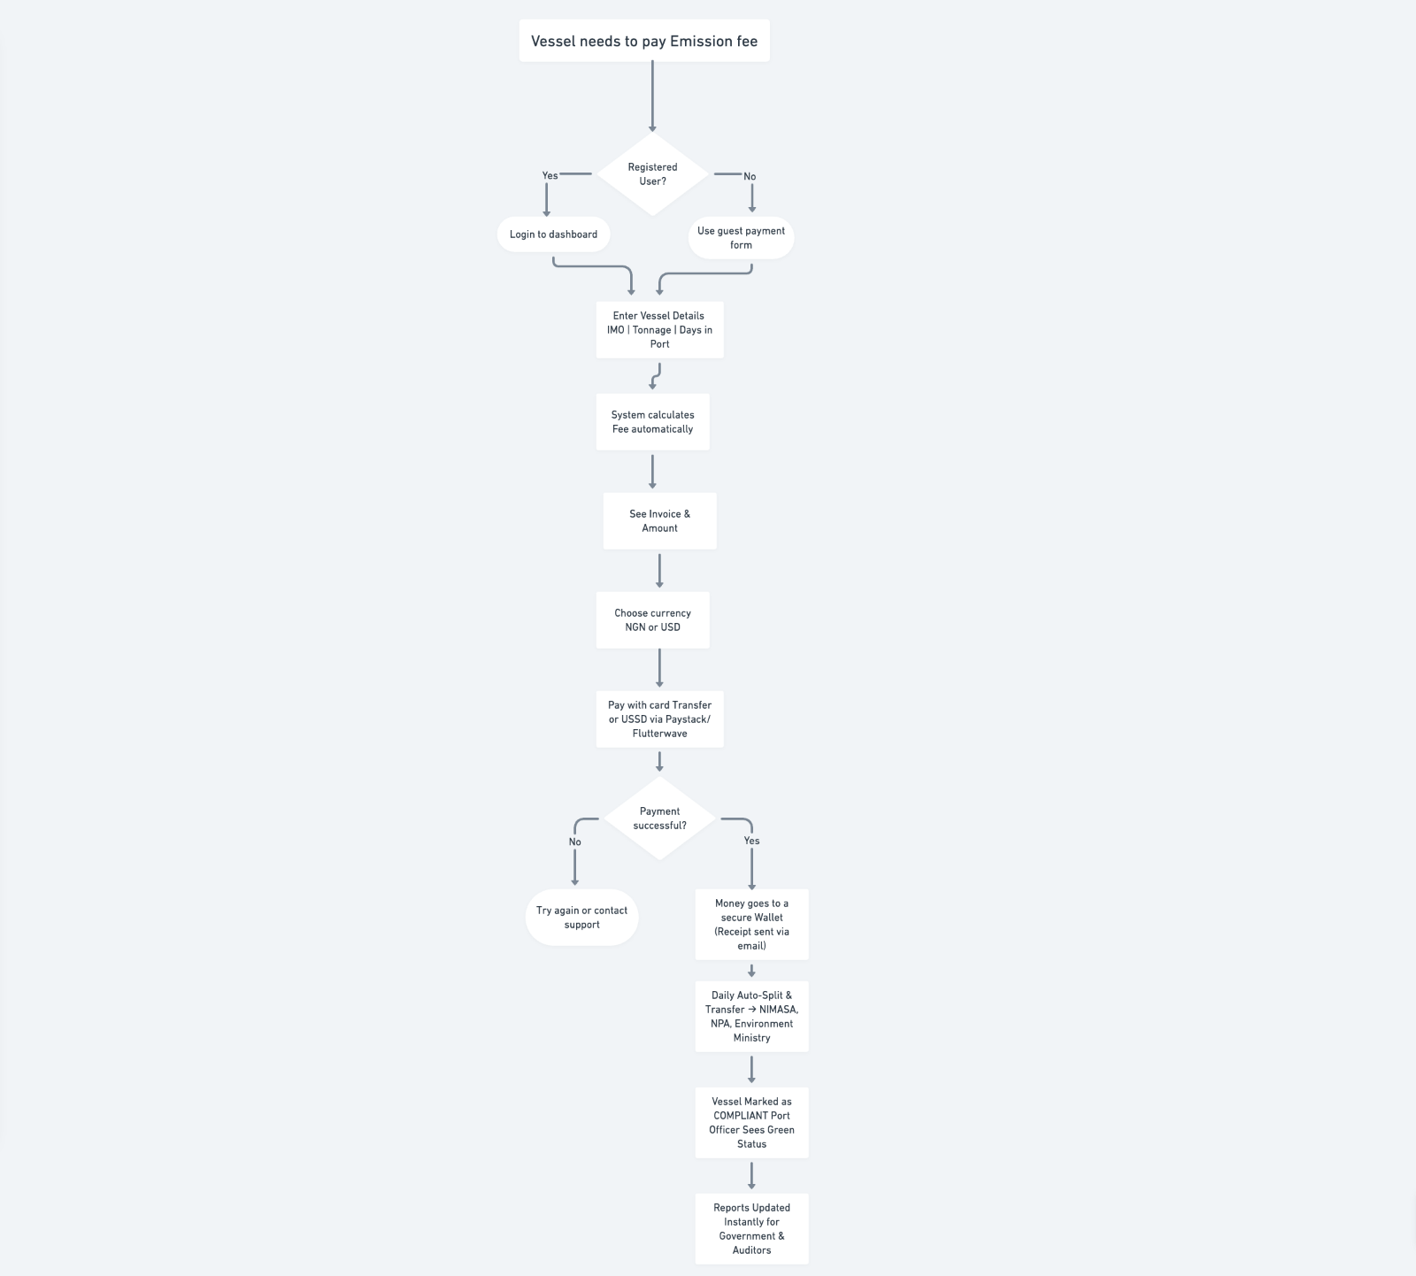
Figure 1: End-to-End Emission Fee Payment Process
3. User Personas
To ensure the platform meets the needs of all stakeholders, we’ve defined key user personas representing different user types and goals:
1. Port Authority Officer
Responsible for monitoring incoming vessels and ensuring all ships have paid their required emission fees.
They need to view vessel information, payment status, and compliance reports.
2. Shipping Company Representative
Handles emission payments for multiple vessels.
Needs to quickly generate invoices, make payments, and access receipts without going through complex manual steps.
3. Regulatory Auditor (NIMASA / Environmental Agency)
Reviews payment data, audits compliance records, and ensures the emission fees align with environmental regulations.
They rely on detailed reporting and access to a secure audit trail.
4. Financial Administrator (Government or Partner Agency)
Oversees the flow of funds between shipping companies and government accounts.
Needs accurate settlement reports and automated reconciliation for transparency.
5. System Administrator
Manages user accounts, permissions, and platform settings.
Ensures uptime, data security, and the smooth operation of the platform.
4. Platform Overview
The Ship Emission Fee Collection Platform is a digital solution that connects shipping companies, government agencies, and regulators in one system.
Instead of calculating and paying emission charges manually, shipping operators can log in (or even pay without registration), enter vessel details, view their emission fee, and complete the payment instantly.
The system automatically:
- Calculates the emission fees based on tonnage and environmental data.
- Sends payments to the right accounts through trusted gateways like Paystack or Flutterwave.
- Generates receipts and reports for all parties involved.
For the government, it ensures accurate monitoring of ship emissions, improved transparency, and higher revenue collection efficiency.
For shipping companies, it provides a simple, digital process that saves time and reduces human errors.
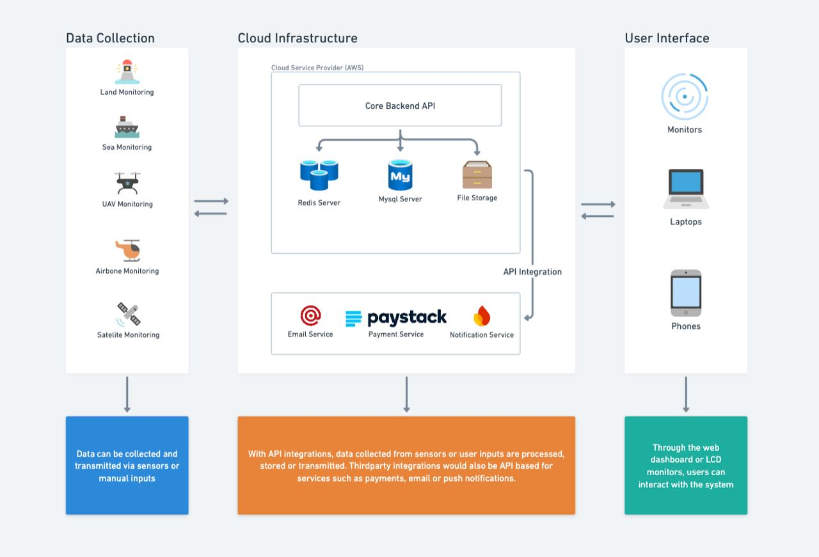
Figure 2: Simplified System Architecture

5. Feature Requirements & User Scenarios
This section explains what users can do on the platform in practical, day-to-day terms — focusing on real actions instead of technical processes.
The goal is to help every stakeholder easily understand how the platform works and what value each feature delivers.
1. User Management
The platform allows all types of users — from shipping companies to government agencies — to register, log in, and manage their profiles.
- Account Creation: Users can sign up with basic information and verify their accounts via a code (OTP).
- Access Control: Different roles (e.g., Admin, Auditor, Operator) have access only to what they need to see or manage.
- Profile Updates: Users can edit their company or personal information, such as email, phone number, and password.
- Security: Accounts are protected with strong password rules and optional two-factor authentication (2FA).
2. Payment Processing
This is the core of the system — where emission fee payments are made and tracked.
- Fee Calculator: The system automatically calculates how much a ship should pay based on its tonnage and emission data.
- Multiple Payment Methods: Users can pay using Naira, USD, or other supported currencies through gateways like Paystack and Flutterwave.
- Guest Payments: Shipping agents can make payments without registering, similar to how platforms like Remita work.
- Instant Receipts: Every successful payment generates a downloadable receipt and confirmation email.
- Transaction Tracking: Users can view all payments made and check the status (Pending, Successful, Failed).
3. Wallet & Settlement Management
The wallet system helps manage how funds are received, held, and distributed automatically.
- Virtual Wallets: Each registered entity (e.g., shipping company, agency) gets a wallet to manage its transactions.
- Revenue Splitting: Payments can be automatically divided between different government accounts or partners.
- Automated Settlements: At set times (daily or weekly), funds are automatically moved from wallets to the appropriate accounts.
- Escrow Holding: Payments may be held temporarily for verification before being released.
4. Reporting & Analytics
Transparency and visibility are key. The reporting tools help stakeholders monitor revenue, compliance, and ship activity in real time.
- Transaction Reports: Displays payment summaries with date, amount, and payer details.
- Compliance Reports: Helps regulators see which ships have paid and which are pending.
- Financial Statements: Shows total fees collected, distributed, and outstanding.
- Data Export: Reports can be downloaded in PDF or Excel for record keeping or audits.
5. Administrative Tools
The Admin Dashboard gives authorized users full control over the system.
- User Management: Add, remove, or suspend accounts.
- System Configuration: Manage settings like exchange rates, fee rules, and payment options.
- Audit Logs: Keep track of all activities for accountability and compliance.
- Notifications: Send updates or alerts to users about payments, deadlines, or changes.
6. Security & Compliance
The platform is designed with strong security measures and regulatory compliance in mind.
- Data Encryption: All user and transaction data are encrypted end-to-end.
- Activity Monitoring: Suspicious activities trigger alerts for admin review.
- Compliance Standards: Built to align with NDPR and financial data security regulations.
- Audit Trails: Every transaction and system action is recorded for transparency.
7. Customer Support & Communication
To make the experience smooth for all users, the platform includes built-in support tools.
- Help Center: Users can access FAQs and guides on how to make payments or generate reports.
- Support Tickets: Users can raise issues or questions directly through the dashboard.
6. Technical Overview
The platform will be built using secure, scalable web technologies suitable for both mobile and desktop access. While the initial version will rely on trusted existing payment gateways like Paystack and Flutterwave, it will be designed to support future integration with a proprietary payment engine. Core principles guiding the build include:
- Security First: All data and transactions are encrypted.
- User-Centric Design: Simple, intuitive user flows.
- Scalability: Can handle large transaction volumes across ports.
- Interoperability: Built to integrate with other government or maritime systems in future.
7. Project Planning & Milestones
Phase 1 – Core Platform Build (Weeks 1–3)
- Setup CI/CD pipeline and architecture
- Implement user management & authentication
- Integrate Paystack & Flutterwave gateways
- Create transaction logs & admin dashboard
Phase 2 – Settlement & Wallet (Weeks 4–5)
- Develop revenue split rules engine
- Build wallet subsystem & escrow flow
- Implement daily reconciliation scripts
- Add transaction and settlement dashboard
Phase 3 – Advanced Features (Weeks 6–8)
- Create recurring billing & invoice module
- Add notification and alert services
- Implement audit trails and role management
Phase 4 – Testing & Launch (Weeks 9–10)
- Perform QA, performance, and penetration testing
- Conduct UAT and go-live readiness
- Deploy production environment and monitoring dashboards
Acceptance Criteria
- Users can register, initiate, and complete payments successfully.
- Admins can view real-time reports and settlements.
- Funds split automatically based on defined rules.
- Reconciliation reports are accurate within 24 hours.
- All transactions logged and auditable.
8. Role-Based Access and Feature Permissions
Super Admin
- Full control over all configurations, integrations, and settings.
- Manages all users, wallets, settlements, and compliance policies.
- Access to all audit logs and reports.
Agency / Merchant Admin
- Manages organization-level transactions, payments, and revenue splits.
- Can create sub-users and view settlement history.
- Limited to their own organization scope.
Operator
- Handles daily operations like refunds, payment verifications, and support.
- Cannot modify configurations or access financial settings.
Auditor
- Read-only access to all logs, reports, and historical data.
- Cannot initiate or edit any transactions.
Developer Partner
- API documentation and sandbox access.
- Can simulate payments in test mode but not access live data.
9. Guest / Non-Registered Payment Feature
Allows users to make payments without registration — similar to Remita or Paystack checkout flows.
Key Capabilities
- Public “Pay Now” form or link for quick one-time payments.
- Secure public API endpoint for initiating guest transactions.
- Auto-generated transaction reference and reconciliation tracking.
- Email/SMS receipts sent upon successful payment.
- Guest transactions visible in admin reports and tagged “Public Checkout.”
10. MVP Feature Scope
1. Authentication & User Management
- User Login via email and password
- OTP verification for security
- Password reset and change functionality
- Secure Logout and session timeout
- User registration
- Role-based access and permissions
- Profile management for personal details
- Optional 2FA for admin-level users
2. Dashboard & Navigation
- Admin dashboard with transaction summaries
- Operator dashboard for reconciliation
- Merchant dashboard for invoices and wallets
- Collapsible navigation menu
- Notifications panel for alerts
3. Payment Features
- Paystack and Flutterwave integration
- Guest payments (no registration)
- Reusable payment links
- Card, bank transfer, and USSD support
- Multi-currency (NGN & USD) support
- Transaction history with filters
- Downloadable receipts
- Retry failed payments
- Webhook handling and auto updates
- Transaction exports (CSV/Excel)
4. Wallet & Settlement
- Auto-created virtual wallets
- Real-time balance display
- Automatic wallet-to-bank settlement
- Escrow holding for verification
- Custom settlement rules per stakeholder
- Daily automated settlements
5. Reporting & Analytics
- Transaction summary and status tracking
- Revenue split and stakeholder reporting
- Wallet activity logs
- Exportable reports (CSV/PDF)
- Audit logs for compliance
- Optional visual analytics
6. Invoice & Billing
- Manual invoice creation and tracking
- Unique invoice reference numbers
- Shareable invoice payment links (URL or QR)
- Payment status tracking
- Optional recurring billing setup
7. Admin & System Management
- Role management and access control
- API key creation and revocation
- Gateway configuration for Paystack and Flutterwave
- System audit trails for key actions
- Configurable notification settings
8. Security & Compliance
- AES-256 data encryption
- TLS 1.3 secure HTTPS enforcement
- Detailed activity logging
- PCI-DSS compliance readiness
- 2FA for admin users
- Data Privacy & Retention: Platform must comply with NDPR and GDPR standards where applicable. Personal data should be collected only for defined purposes and stored securely. Define retention periods for transaction logs and PII, and support anonymization and data-erasure requests based on user rights.
- Data Access Control: Apply least-privilege access across user roles to ensure sensitive data is restricted to authorized personnel only.
9. Notifications & Communication
- Automated payment confirmation emails
- Failure and settlement notifications
- System alerts for errors or downtime
- Optional SMS notifications
10. Developer & Integration Tools
- RESTful public API for payments
- Webhooks for transaction status updates
- API key and token management
- Developer documentation (Swagger/Postman)
- Sandbox environment for testing integrations
MVP Completion Criteria
- Guest and registered users can complete payments successfully.
- Admins can monitor, reconcile, and settle payments.
- Reports and receipts generated accurately.
- Revenue split and settlement automation functional.
- System logs, security, and uptime meet performance standards.
11. MVP Build Sequence
This sequence focuses specifically on the MVP delivery phase within the overall project plan described earlier. While the “Project Planning & Milestones” section outlines the complete roadmap for the full Liquid Payments Platform, the MVP Build Sequence below defines the first 10-week implementation cycle, concentrating on essential features needed for a functional product launch.

MVP Build Plan
Phase | Timeline | Goal / Focus | Key Tasks | Deliverables
Phase 1: System Setup & Authentication | Weeks 1–2 | Establish foundational architecture and secure user access | - Setup backend environment and CI/CD pipelines  - Implement user authentication (login, registration, password reset)  - Add role-based access control (RBAC)  - Configure QA environment | - Working login and registration modules  - Admin dashboard shell  - CI/CD pipeline tested
Phase 2: Payment Gateway Integration | Weeks 3–4 | Enable real-time payment collection and verification | - Integrate Paystack and Flutterwave APIs  - Implement webhook listeners for transaction callbacks  - Build Guest Payment flow (no registration)  - Generate receipts and transaction confirmation emails | - Payments functional with callbacks  - Guest payment tested successfully  - Receipts generated and recorded
Phase 3: Wallet & Settlement Engine | Weeks 5–6 | Establish financial management and automated distribution logic | - Build wallet management system for stakeholders  - Implement settlement rules and escrow logic  - Automate payouts and balance updates | - Wallets operational with escrow  - Settlement rules functional  - Daily settlement automation verified
Phase 4: Reporting & Admin Tools | Weeks 7–8 | Provide operational visibility and compliance reporting | - Develop analytics dashboard for Admins and Operators  - Enable CSV/PDF export of transaction reports  - Implement system audit trail for all admin actions | - Reporting dashboard live  - Exports functional  - Audit logs working correctly
Phase 5: Security, Notifications & QA | Weeks 9–10 | Harden the system and prepare for production launch | - Apply AES-256 encryption and enforce HTTPS  - Enable 2FA and IP whitelisting  - Add notification system for payments and downtime  - Conduct performance, regression, and penetration testing | - Security checks passed  - Notifications active  - Production-ready deployment completed
Total Duration: 10 Weeks (2.5 Months)
Core Team:
- 2 Backend Developers
- 1 Frontend Developer
- 1 DevOps Engineer
- 1 QA Engineer
- 1 Product Manager
Launch Outcome: By the end of this build cycle, the Liquid Payments MVP will support end-to-end payment processing (guest & registered), wallet settlement, admin management, and reporting — ready for operational use and stakeholder testing.
Payment Quality Assurance
- End-to-End Testing: Validate all payment paths – success, failure, refund, and partial payments – across Paystack and Flutterwave.
- Reconciliation Accuracy: Ensure daily reconciliation matches gateway and internal records 100%.
- Data Consistency: Confirm payment references, webhook responses, and status updates remain synchronized.
- User Acceptance Testing: Conduct structured UAT with test merchants before production release.
- Resilience Checks: Simulate gateway downtime and network timeouts to verify retry logic and fault recovery.

